RIT Idle

# Concept

# This is an idle game where you play as a RIT freshman majoring in GDD. You “enroll in” classes (levels) to do exercises (enemies) of different levels, gain experience and tiger spirit. To beat the game, you must finish all your bachelor classes.

# Genre

Idle, Adventure, RPG

# Platform

Desktop web. 1600x900

# Story

The idea is to enjoy the gameplay, so no story included.

# Aesthetics

Pixel and simplistic arts (simple shapes)

# Gameplay

The only control needed is the Left Mouse Button. The player makes decisions on which class to take (one at a time), which ability to practice and different classes benefit from different abilities. They can purchase ability upgrades as a multiplier on the ability value with tiger spirit. Higher levels unlock more powerful upgrades and more demanding (also more rewarding) classes. Each class has a problem-solving speed cap, restricting the max gain from a certain ability.

At a certain point of the game, the player will unlock “déjà vu”, which can restart the journey with a boosting factor based on their total exp earned. Engaging in the game gives extra rewards but the player can literally “idle” through the game. Going offline also gives rewards based on time.

Mockups

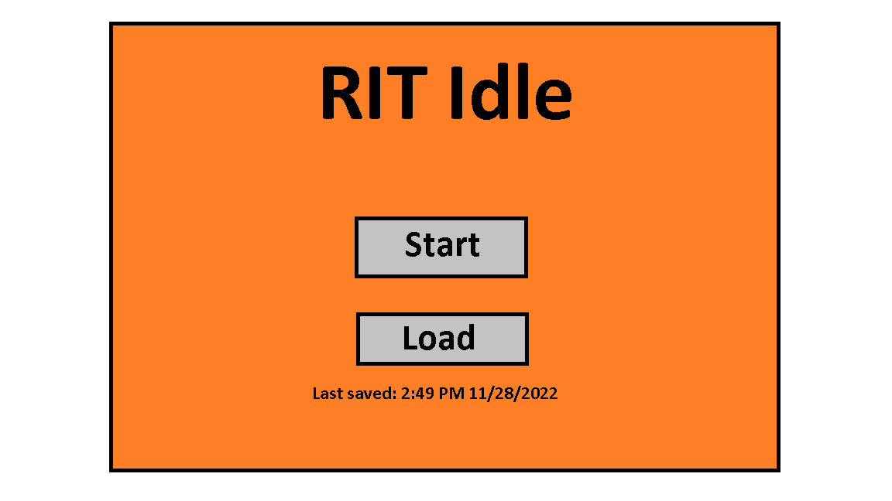

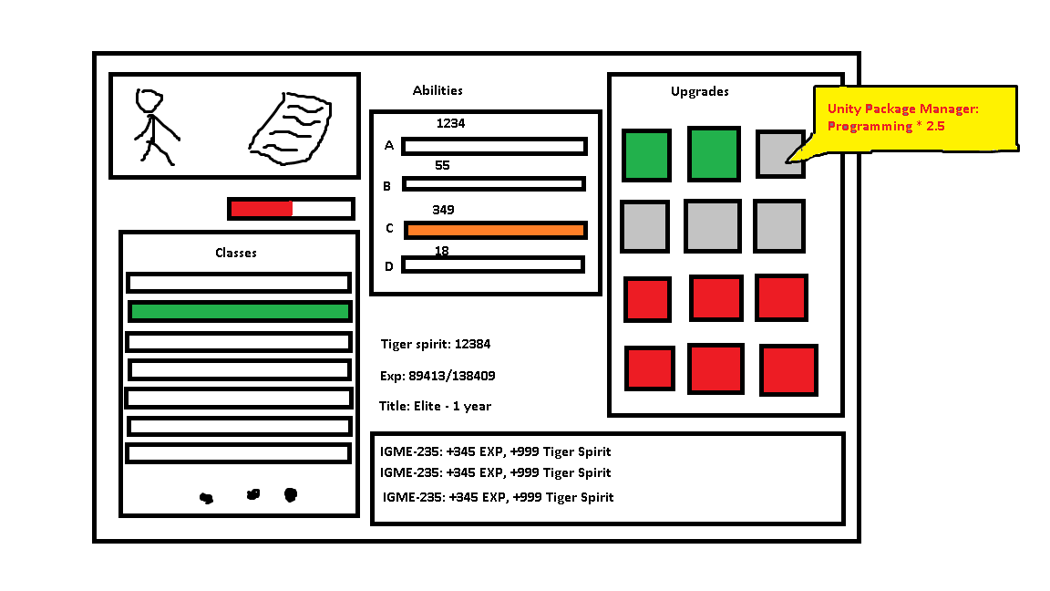

# About

Zhao Jin, Game Design & Development, sophomore.

Skills/interests: Javascript, C#, Unity, Photoshop, Aseprite…